USAID GLOBAL HEALTH SUPPLY CHAIN PROGRAM

Procurement and Supply Management

|  |
| --- |
| Dispatch Optimizer User Guide  November 2022 |

The USAID Global Health Supply Chain Program-Procurement and Supply Management (GHSC-PSM) project is funded under USAID Contract No. AID-OAA-I-15-0004.  GHSC-PSM connects technical solutions and proven commercial processes to promote efficient and cost-effective health supply chains worldwide. Our goal is to ensure uninterrupted supplies of health commodities to save lives and create a healthier future for all. The project purchases and delivers health commodities, offers comprehensive technical assistance to strengthen national supply chain systems, and provides global supply chain leadership.

GHSC-PSM is implemented by Chemonics International, in collaboration with Arbola Inc., Axios International Inc., IDA Foundation, IBM, IntraHealth International, Kuehne + Nagel Inc., McKinsey & Company, Panagora Group, Population Services International, SGS Nederland B.V., and University Research Co., LLC. To learn more, visit [ghsupplychain.org](http://www.ghsupplychain.org/)

DISCLAIMER:  
The views expressed in this publication do not necessarily reflect the views of the U.S. Agency for International Development or the U.S. government.

Contents

Contents 1

Overview of Dispatch Optimizer 2

Overall Workflow 2

Tool Log-in 3

Order Evaluation 3

Upload File 5

Refine Data 6

Solve Optimization 7

Review Results 8

Data Administrator View 8

Working with Scenarios 9

Data Model 9

Overview of Dispatch Optimizer

In health supply chains, transportation planning is just one step in a complex set of logistics processes that ensure essential health commodities get from warehouses to the public health facilities which order them. In planning outbound transportation, supply chain professionals must determine the sequencing and grouping of destinations into dispatches, as well as the vehicle type to use for each delivery. This planning must be coordinated with a set of warehouse activities such as order validation, pick wave assignment, picking, packing, staging and loading. In the absence of planning tools, users have to make these decisions based on historical experience and intuition. The Dispatch Optimizer provides a way for users to make data-driven decisions about dispatches from the warehouse.

Users load a list of orders into the tool, follow the guided user experience, and then solve for the optimal set of dispatches and review the results. The suggested dispatch groupings and sequences, along with truck assignments, can then inform warehouse picking and packing activities and the ordering of appropriate delivery vehicles to facilitate delivery of health commodities to the hubs and service delivery points.

The Dispatch Optimizer helps users determine:

• How to group facilities into dispatches?

• How to sequence those facilities within the dispatch?

• What vehicle to use for each dispatch?

Overall Workflow

The tool takes users through the following workflow via an interactive web application.

1. User Logs in.
2. User uploads a list of orders on the Order Evaluation page.
3. User makes selections about which sets of facilities to include, and downloads the “Order Evaluation Tool.”
4. User uploads validated Order Evaluation File.
5. User refines the data to specify which trucks should be used.
6. User solves the optimization problem.
7. User reviews results.

Depending on the context, some of these steps may be skipped. A configuration file contains parameters which will determine which features will be active.

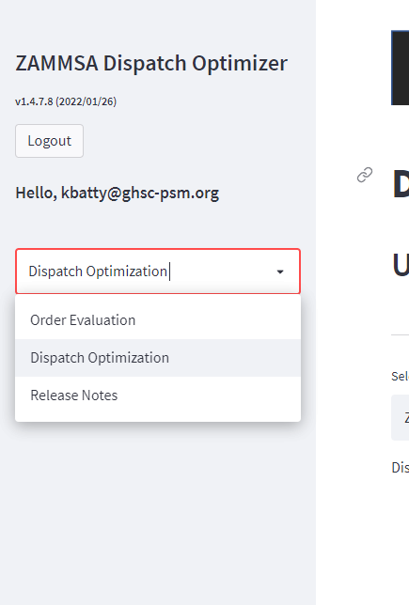

*Figure 1: Left-side navigation menu*

Tool Log-in

When user first visits the web app URL, they should enter their username and password. The valid usernames and passwords are defined on the credentials file.

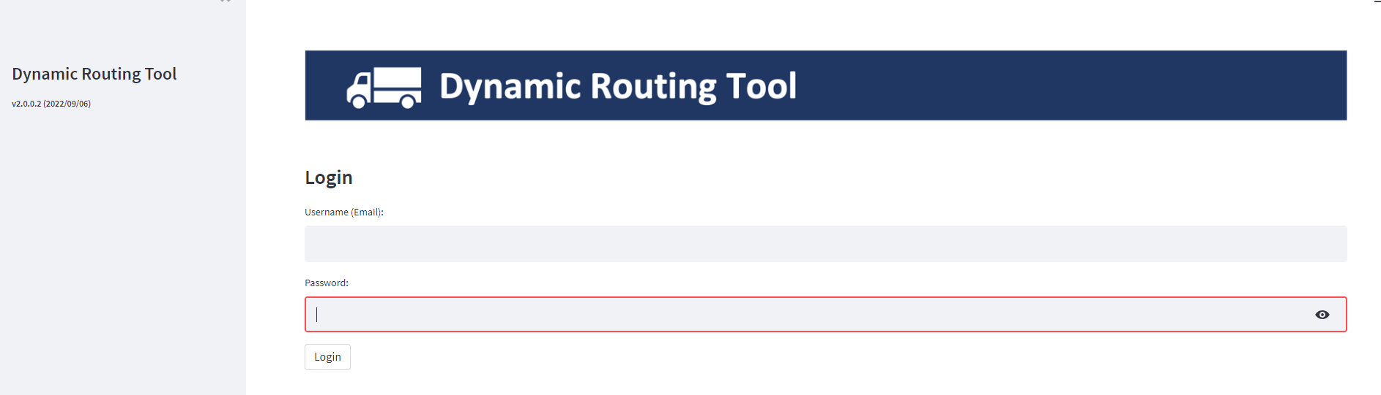

*Figure 2: Log-in Screen*

Order Evaluation

After logging in, the user will be shown the Order Evaluation screen. On this screen, the user will upload a set of orders. This will trigger the tool to look up the relevant order details, such as the destination facility and the estimated volume of each order.

The underlying code can be adjusted to allow for different file structures that match the supply chain context. The most simple eligible file structure is an xlsx file with at least one sheet that contains two columns: (*Order ID* and *Route*—*Order ID* should match the identifiers present in the COUNTRY DRO ORDER DETAILS file. *Route* can be any descriptor or categorization that user find helpful (e.g., District or Province name).

After uploading the list of orders, the user will be presented with a graph summarizing the estimated volume, by destination. The user clicks the download button to download the Order Evaluation Tool, which is a standalone Excel document.

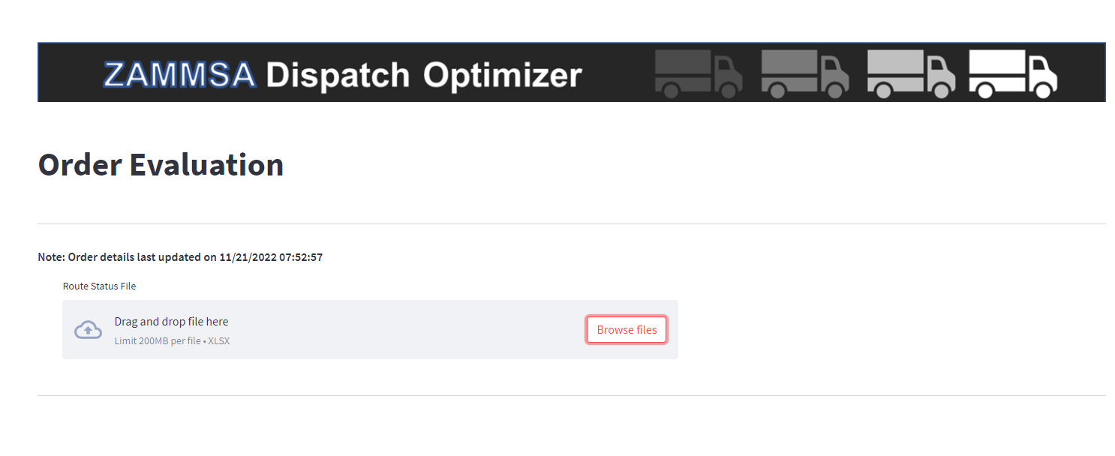

*Figure 3: Order Evaluation Screen*

After opening the Excel tool, users will be presented with a list of deliveries. The user can double-click a delivery record to see the underlying orders. The user can double-click an order record to see the underlying order lines. On the order line page, users can adjust the volume to address data errors or other factors. On the delivery screen, the user can change the destination of a delivery (E.g., if delivery needs to be sent to a District Health Office rather than the facility itself). In certain configurations of the tool, users can specify that a certain facility needs to be visited by a “dedicated truck” rather than as part of a multidrop route.

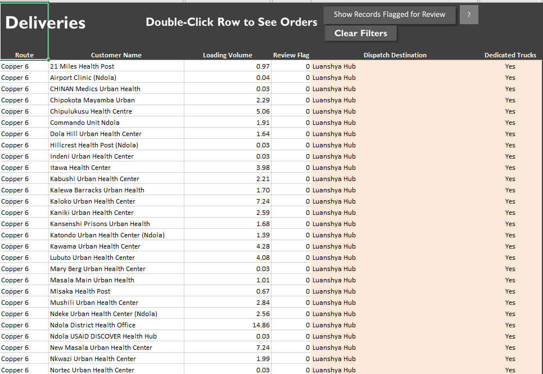

*Figure 4: Order Evaluation Screen*

Once the user is satisfied that this data reflects the actual dispatch needs, the user should save the Excel document to their local machine and return to the web app.

Upload File

After uploading the Order Evaluation file on this page, the user will be presented with a list of facilities and their associated volumes. The facilities will be plotted on a map.

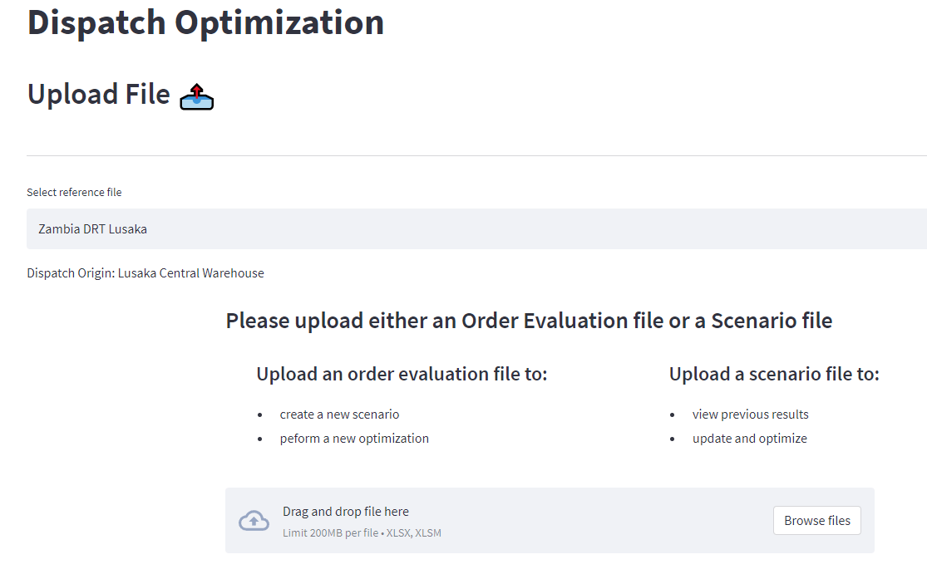

*Figure 5: Upload File for Dispatch Optimization*

On this screen, the user can de-select a facility if they do not wish to include it in the optimization. When the user is satisfied with the list of scenarios, they should click “Initialize Scenario,” which creates and saves a new scenario which will be tracked through the subsequent process.

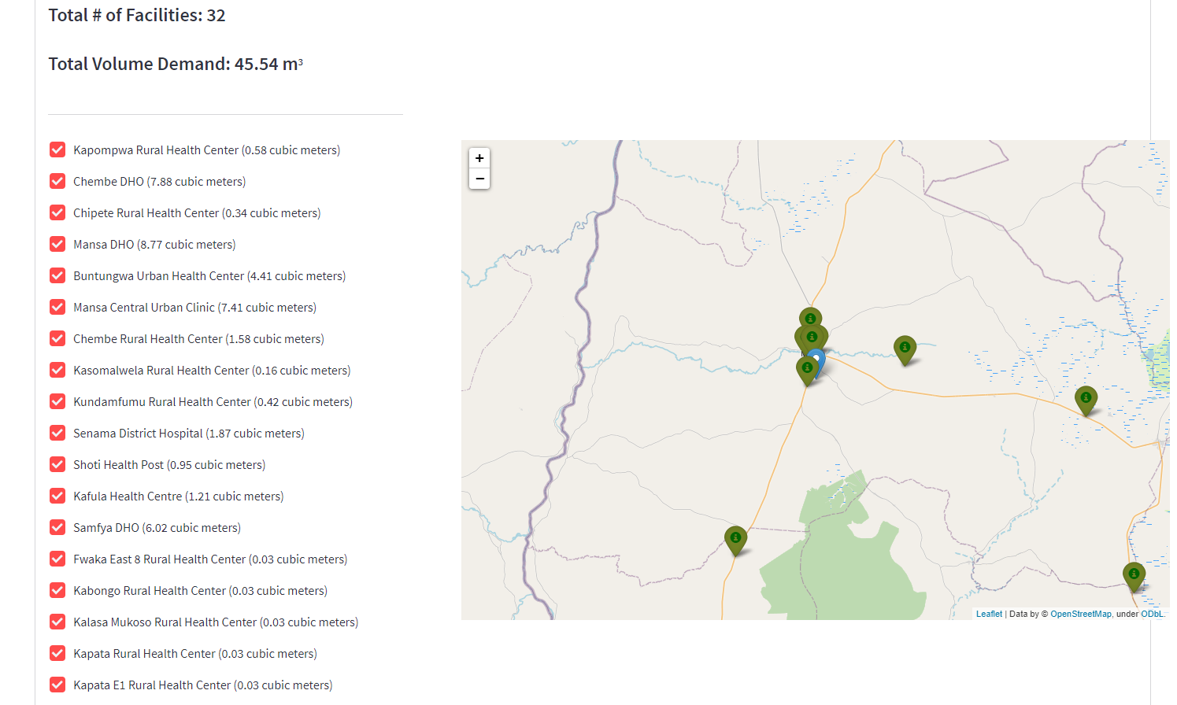

*Figure 6: Review facility list, locations and volumes before initializing*

Refine Data

The Refine Data screen gives user a chance to refine the rules by which the routes are optimized. In the latest version of the tool, this mostly focuses on vehicle usage. The user has two mechanisms via which to define which vehicles can be used to make deliveries. First, a given vehicle type can be broadly allowed or disallowed by using the check box. Alternatively, the user can use the dropdowns to exclude specific vehicles from delivering to specific facilities.

Note: The model can also be configured to exclude certain facility/vehicle combinations by default.

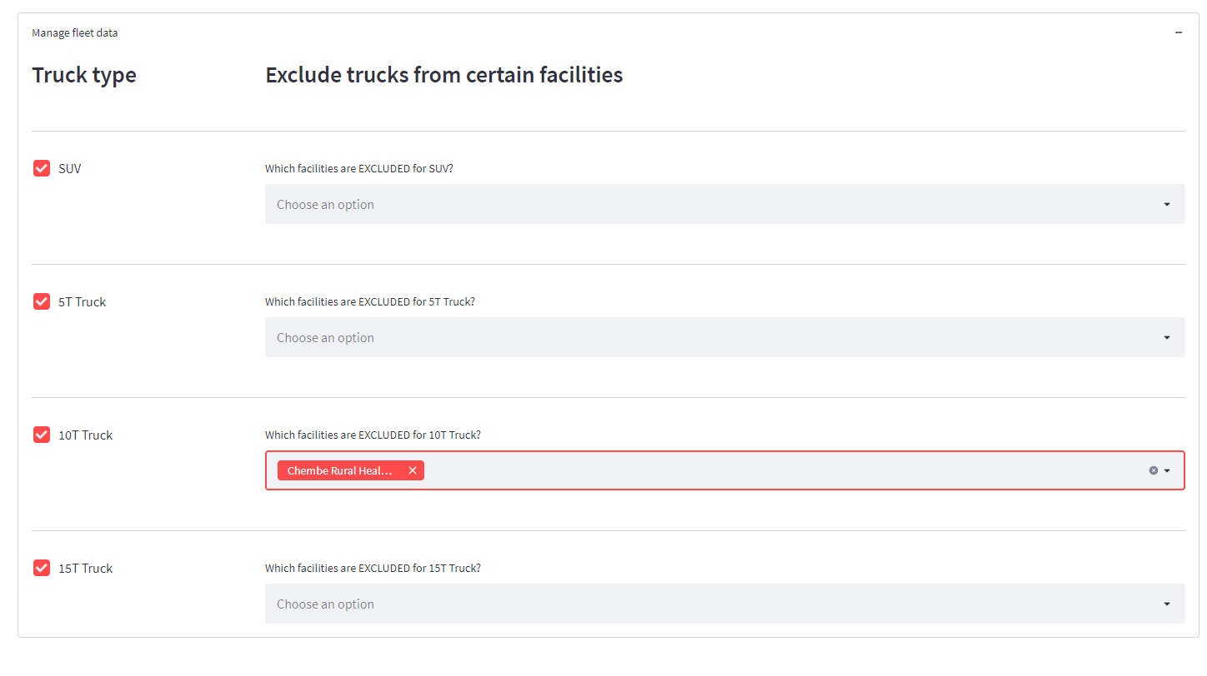

*Figure 7: Refine data by defining ineligible facility/vehicle combinations*

Solve Optimization

On the Solve Optimization page, the user clicks to initiate the processing and solving of the optimization model. It is recommended to set the Optimization Runtime Limit to 60 seconds or more, to allow the model enough time to search for an optimal solution.

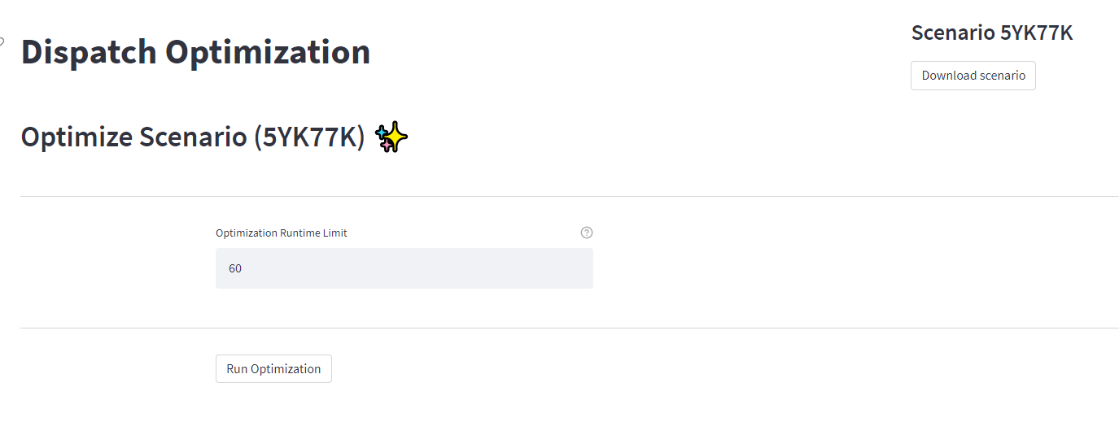

*Figure 8: Solve Optimization screen*

Review Results

The Review Results screen contains a summary at the top and detailed, dispatch by dispatch details below.

The user can select to “Display Dispatches Using Road Network,” which will plot the relevant routes using the approximate actual road network from Open Route Service.

On the top left, the outputs will be summarized in terms of distance, number of dispatches, percent of overall truck utilization (i.e., of all the vehicles being used, what percentage of available capacity is being utilized).

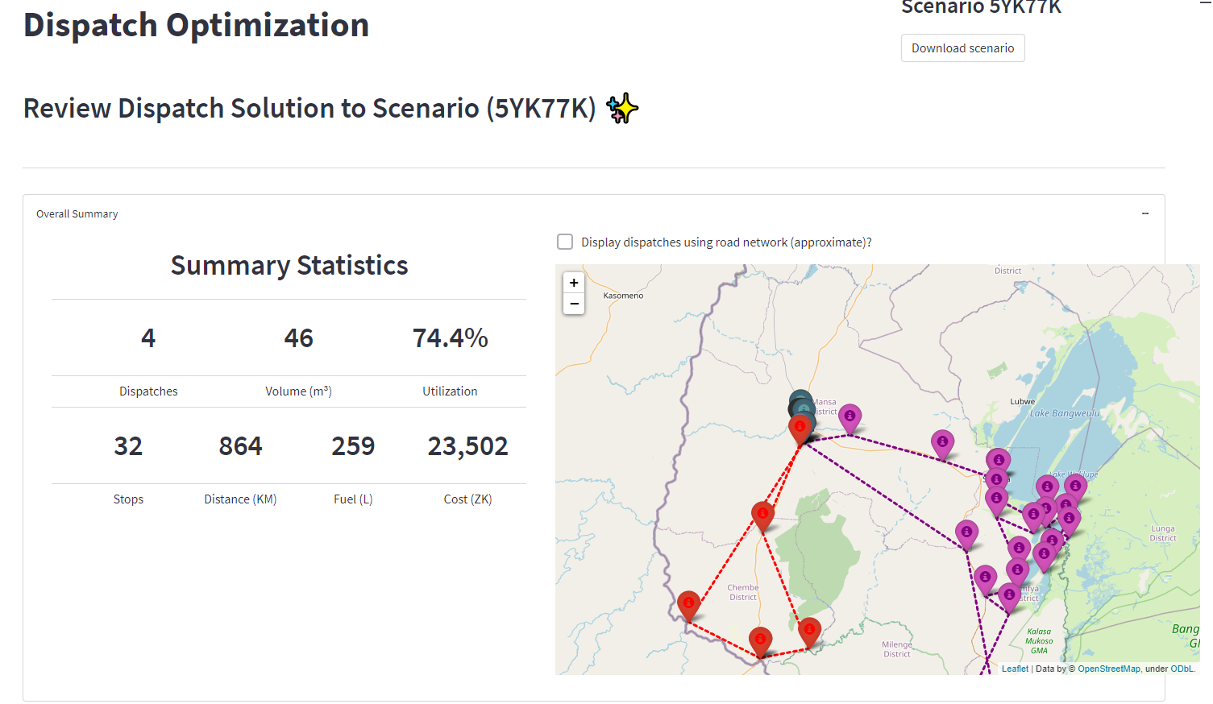

*Figure 9: Review Results Screen*

Data Administrator View

The credentials.ini file defines two different log-in types—user and admin. If the tool is access using the admin password, an additional screen will be available: Tool Administration.

On this page, the admin can follow the simple interface to update any of the reference data by uploading new versions of any table. This could be used to update order details, transportation costs and more.

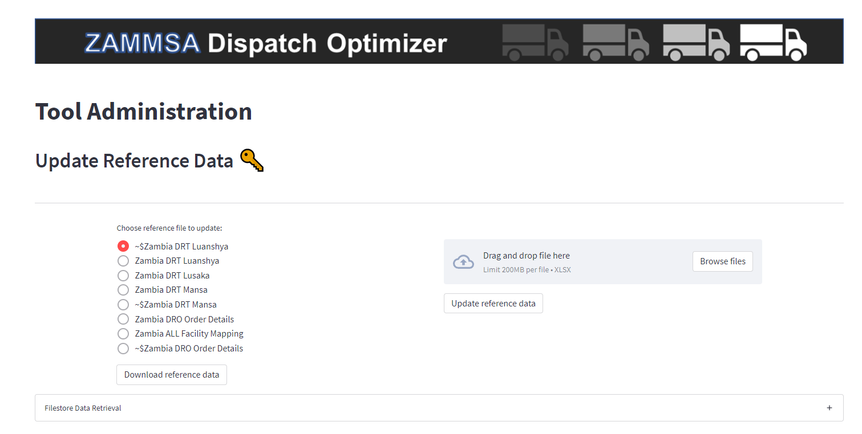

*Figure 10: Data Administrator View*

Working with Scenarios

When the user first uploads the Order Evaluation file and commences the Dispatch Optimization workflow, a scenario is initialized. This scenario persists through the workflow and can be downloaded from the Review Results page so that the underlying data, parameters and solution can be shared or revisited in the future. On the Order Evaluation page, the user has the option of uploading a scenario file instead of an Order Evaluation file, which will load the tool with the same parameters that were set previously. The downloaded scenario file can also be archived to provide an auditable and re-solvable snapshot of the data and parameters that were fed into the optimization model.

Data Model

The zip folder associated with this user guide contains templates for the files below, indicating the specific fields that are required.

In the labels below, “Country” is a generic placeholder for the relevant country in which the tool is being implemented. “Warehouse” is also a placeholder for a specific warehouse name, as there may be multiple warehouses which use the tool.

**COUNTRY ALL Facility Mapping**

This file is used by the tool to determine which facility maps to which warehouse. This is used during the Order Evaluation step in order to determine which volume should flow via which hub.

**COUNTRY DRO ORDER DETAILS**

This table contains all of the order lines which are available for optimization. For each order line, it specifies the customer facility, the item SKU and name, and the associated quantities, weights, and volumes. This table is referenced when the user uploads a list of order numbers during the Order Evaluation step.

**COUNTRY DRO ORDER EVALUATION TEMPLATE**

This is a template which will be automatically populated by the tool. The user will download and interact with the completed template as part of the Order Evaluation steps.

**COUNTRY DRT WAREHOUSE**

If a country has multiple warehouses which will be using the Dispatch Optimizer, there should be a separate file for each warehouse.

* **Facility:** Defines the set of facilities which can receive deliveries.
* **Distance:** Matrix defining distances between every combination of facilities. Indexed in same sequence as main facility table.
* **Time (optional):** Matrix defining travel time between every combination of facilities. Indexed in same sequence as main facility table.
* **Fleet:** List of vehicle types and attributes, including average speed and capacity.
* **Fleet Exclusions:** List of facility/vehicle combinations which should be considered ineligible by default.

*Cubage, Facility Group, Distance Adj, and Parameters can be left unpopulated when executing the main dispatch optimization functionality of tool.*